Lawrence MAYB spring swish
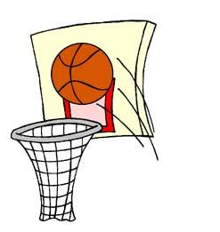 |  | April 27, 2019  3 game guarantee  All games played on saturday  Divisions: 3rd-12th boys and girls  Check out www.visitlawrence.com
Free State High School South Middle School
4700 Overland Dr. 2734 Louisiana St.

Lawrence KS 66049 Lawrence KS 66046

Register: Online at www.mayb.com
Or call 316-284-0354

