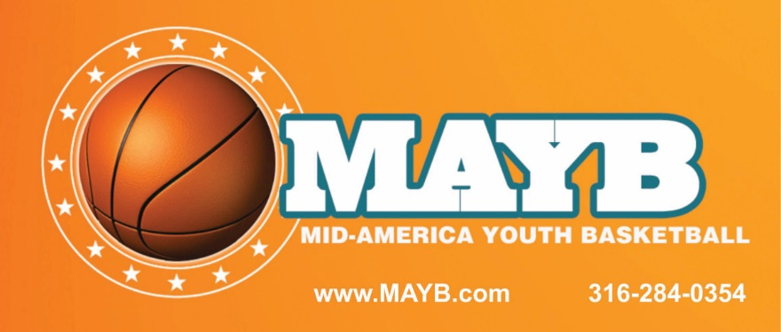
****2018 MAYB Tournament Dates****
***Memphis, TN***
**Boys & Girls: 3rd-12th GR.**
*Spring Tournaments:$175.00 (3) GM. Minimum*
1. March 10-11 Memphis, TN
2. March 17-18 Memphis, TN
3. March 24-25 Memphis, TN
4. April 7-8 W. Memphis, AR
5. April 14-15 Bartlett/Memphis, TN
6. April 28-29 Jackson, TN
7. May 5-6 Memphis, TN
*Summer Tournaments: (3,4&5) GM. Minimum*
8. May 18-20 Memphis, TN
9. June 1-3 Cordova/Memphis, TN
10. June 15-17 Memphis, TN
11. July 6-8 Cordova/Memphis, TN
12. July 20-22 SO. Haven, MS/Memphis, TN
13. July 27-29 Memphis, TN
K.L Jones (901)859-3275
Katerjone@comcast.net Website:Katerjoneshoops.com

